Commuter-Adjusted Population Estimates: ACS 2006-10

Brian McKenzie, William Koerber, Alison Fields, Megan Benetsky, Melanie Rapino
(Journey to Work and Migration Statistics Branch, U.S. Census Bureau)

INTRODUCTION
The concept of the daytime population refers to the number of people who are present in an area during typical business hours, including workers, children in school, people in hospitals or other short-term medical facilities, people temporarily staying in lodging facilities, and customers present at retail locations. This is in contrast to the “resident” population, which refers to people who reside in a given area and are typically present during the evening and nighttime hours. Information on the expansion or contraction of worker populations throughout a typical workday is important for a variety of community planning purposes. These purposes may include, for example, addressing transportation planning issues and disaster relief operations.

The Census Bureau first published daytime population estimates using Census 2000 data. The estimates from Census 2000 are limited to the location of workers in a typical workday. No adjustments were made to account for the time of day commuters worked inside or outside specified areas or geographies. Thus, the estimates from Census 2000 are more accurately described as commuter-adjusted population estimates rather than the more familiar concept of daytime population estimates.
This paper accompanies the release of the Census Bureau’s first commuter-adjusted population estimates based on the American Community Survey (ACS), and the first commuter-adjusted population release since that based on Census 2000. It summarizes commuter-adjusted population estimates for places, minor civil divisions (MCDs), counties, and states based on the 5-year 2006-2010 ACS estimates. The Census Bureau produces 1-year and 3-year ACS datasets, but only the 5-year datasets have a large enough sample to provide reliable estimates for smaller counties, MCDs, and places. The 2006-2010 ACS dataset was selected in order to provide a reasonable comparison with the Census 2000 estimates. The ACS-based estimates use the same methodology as the Census 2000 estimates.

The tables presented include commuter-adjusted estimates and several components and derivations of these estimates such as the ratio of workers to residents in an area. This paper discusses notable patterns of commuter-adjusted population change across several geographic summary levels, as well as the necessary metadata and methods for calculating commuter adjusted estimates. Below are some highlights related to commuter-adjusted population from the 5-year 2006-2010 ACS estimates.

- Among U.S. counties, New York County, NY experienced the greatest percent change between residence population and commuter-adjusted population with a 94.7 percent change.

- Among places with 50,000 population or greater, Redmond City, WA experienced the largest percent change between residence and commuter-adjusted population, at 111.4 percent.

- Among U.S. counties, New York County, NY and Washington, DC have employment-to-resident worker ratios of 2.81 and 2.58, respectively.

OVERVIEW OF COMMUTER-ADJUSTED POPULATION ESTIMATES
Information on expansion or contraction of community populations throughout the course of a day has a varied set of applications. Disaster response and relief agencies such as FEMA and state and local agencies use population information to direct resources for disaster relief. Private retailers and other entities benefit from information about the location of potential customers by improving their understanding of their potential customer base for a given area. Metropolitan planning organizations and developers use information about daily flows of workers in and out of communities to gauge the amount of pressure placed on local infrastructure and determine unmet development needs.
The Census Bureau has provided commuter-adjusted population estimates based on the 2000 Census. The annual ACS releases now makes it possible to update such estimates more regularly. The ACS is an ongoing survey conducted annually by the U.S. Census Bureau that captures changes in the socioeconomic, housing, and demographic characteristics of communities across the United States and Puerto Rico. Among topics covered by the ACS are several related to commuting, including workplace location. Commuter-adjusted population estimates depend on coupling information about workers’ place of residence and place of work. The 5-year 2006-2010 ACS-based estimates that accompany this paper represent a relatively fundamental conceptualization of commuter-adjusted population. They capture the base population for an area (the residence population), adjusted for the number of persons who commute into and out of that area. These estimates provide a basis for more detailed future estimates that may potentially incorporate an extensive set of community characteristics, but are beyond the scope of our immediate project and much of the data available from the ACS.

DEFINITIONS FOR THE COMMUTER-ADJUSTED POPULATION
Commuter-adjusted population estimates and their derivations include the following components.

Worker
Workers in this analysis are civilians and members of the Armed Forces, 16 years and over, who were at work the previous week. Persons on vacation or not at work the prior week are not included.

Total Area Population/Residents
The resident population is defined as the number of people living in a specified geography.

Total workers working in area
The total number of workers working in an area includes all workers who indicate a specified area as their place of work regardless of where they live.

Total workers living in area
The total workers living in a specified geography is defined as the number of workers who are also residents. This estimate does not reflect location of work.

CALCULATING COMMUTER-ADJUSTED POPULATION
Commuter-adjusted population estimates are derived from three ACS-based population components, each presented in the following equation:
(Commuter-adjusted population = Total area population + Total workers working in area – Total workers living in area)
Each of these components is available from the ACS for counties and several other geographic summary levels and may be accessed on American Factfinder. Individual population components that underlie commuter-adjusted population estimates are listed below. These components either supplement the understanding of commuter-adjusted population estimates or contribute to its calculation.
- Change in county population due to commuting
- Percent of county commuter-adjusted population change due to commuting
- Total number of workers working and living in a given county
- Percent workers who lived and worked in a given county
- Ratio of employment to residence (=Percent workers working in county/percent workers living in county)

ACS 2006-10 COMMUTER-ADJUSTED POPULATION TABLES AND COMPARABILITY WITH CENSUS 2000

For places, MCDs, counties, and states tables of commuter-adjusted population estimates and related components based on the 5-year 2006-10 ACS are available in pretabulated format on the Census Bureau’s Commuting web page. Tables based on the 5-year ACS are limited to areas with residence populations of 2,500 persons or larger or worker populations of 2,500 persons or larger. Commuter-adjusted population estimates are unrounded and accompanied by margins of error. All tables are available for download as CSV and Microsoft Excel files. The Census Bureau’s Commuting Web Page also includes an example of how to calculate commuter-adjusted population for a county.

Data users should exercise caution in comparing ACS data with data from the decennial census or other sources. Differences in the universe, question wording, reference periods, and tabulation methods can impact comparability between Census 2000 and ACS estimates. Information about comparisons across datasets is available from the Census website. ACS estimates related to daytime population are accompanied by a margin of error in their source table found on the Census Bureau’s commuting web page. When drawing conclusions about small differences between two estimates users should keep in mind that estimates may not be statistically different.

PATTERNS IN COMMUTER-ADJUSTED POPULATION CHANGE FROM ACS 2006-10
For many geographic areas, a population adjustment that accounts for inflows and outflows of workers results in only modest differences between residence population and commuter-adjusted population. Table 1 highlights the relationship between residence population and commuter-adjusted population for each of the geographic summary levels provided for states, counties, MCDs, and places. Among states, only the District of Columbia experienced a statistically significant gain in population that exceeded 1.05 due to commuting. Among other geographic areas, 286 counties, 880 MCDs, and 3,030 places experienced population gains due to commuting. This suggests that small areas contribute to the population of relatively few larger areas with regard to commuter adjusted population.

Commuter-adjusted population is largely a function of residence population, and the difference between the two varies little for most places. Still, there are places in which commuter-adjusted population and residence population differ significantly. Most notably, the commuter-adjusted population of New York County, NY (Manhattan) was about twice as large as its residence population at 3,083,102 and 1,583,345, respectively. This increase was largely due to a substantial number of workers commuting to Manhattan from other counties within New York City. Workers traveling to Manhattan from Brooklyn (Kings County), Queens (Queens County), and the Bronx (Bronx County) account for the nation’s three largest county-to-county commuting flows. Together, they contribute an estimated 952,871 workers to Manhattan’s commuter-adjusted population estimate.
Table 2 shows 25 counties among those with the highest percentage of population change due to commuting, for counties with residence populations of 50,000 or greater. New York County, NY topped the list, at 94.7 percent change, reinforcing its role as an area of high employment concentration and strong labor market pull, attracting workers from outside the county. The population of Washington D.C. also increased considerably when taking commuting into account, with about a 79.0 percent increase from its residence population. Other counties on the list represent a wide variety of regions and population sizes. Several counties such as Fulton County, GA; St. Louis city, MO; Denver County, CO; and Hennepin County, MN include the principal city of large metro areas (Atlanta, GA. St. Louis, MO, Denver, CO; and Minneapolis, MN respectively). Others such as Christian County, KY, and Cole County, MO have relatively small populations and do not have a commuting tie to a large metropolitan area. Several relatively small independent cities in Virginia are also included.
Figure 1 illustrates the relationship between resident population and commuter-adjusted population in a slightly different way. For every county in the United States, the map shows the numeric difference between resident population and commuter-adjusted population. Clear regional and local patterns of population shifts emerge. For example, the heavily urbanized Northeastern corridor from Virginia to the New England States shows numerous clusters of adjacent counties that show population loss surrounding a relatively small number of counties that experience considerable gains in population. Counties such as Suffolk, MA, New York, NY, Baltimore, MD, Philadelphia, PA, and the District of Columbia attract large numbers of workers from surrounding suburban counties, forming a series of adjoining labor markets.
Several metropolitan areas contain a single county that attracts a considerable number of workers from numerous surrounding counties. Such commuting hotspots are evident on the map where a single county colored blue (representing population gains) is surrounded by several counties colored red or orange counties (representing population losses). In metro areas such as Salt Lake City, Omaha, Dallas, St. Louis, and Minneapolis, a single centralized county attracts considerable worker flows from surrounding counties, which are in many cases, more residential and of lower population density. Large metro areas such as Los Angeles, San Francisco, Chicago, and Miami contain clusters of two or more centralized counties that attract large worker flows from outlying counties.
Several states in the West and Midwest contain large geographic expanses with relatively little differences between residence and commuter-adjusted populations. This pattern is linked to a lack of large employment clusters and low populations in these areas. The map illustrates the net direction (population gain or loss) and absolute scale of population change for counties, but it should be noted that the map does not indicate the nature of the worker interchange between counties. For some county pairs, this may obscure the reciprocal nature of worker flows between counties and discount large inflows of workers into counties that experience a net commuter-adjusted population loss due to a large number of workers leaving the county for work.

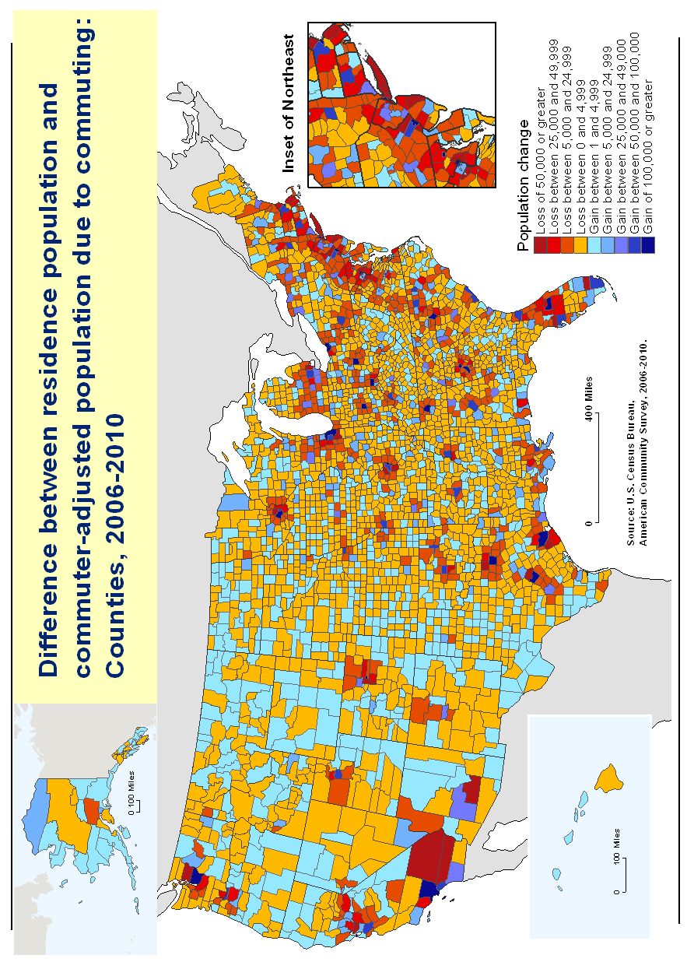
Figure 1.

Shifting the focus from counties to places, Table 3 shows places with populations of 50,000 or greater among those with the largest gains in the percent population change due to commuting. The list of places is diverse in terms of region and population. Redmond City and several other cities in Table 3 have relatively small populations, but are home to one or more large institutions that attract workers from surrounding communities. The list includes several smaller cities that are located within large metropolitan areas, but are not the largest city within that metropolitan area. Redmond City, WA tops the list with a 111.4 percent increase in population due to commuting. Redmond City is in the Seattle metropolitan area and is home to the Microsoft Corporation and other employers that attract large numbers of workers. Palo Alto, located outside of San Francisco is home to a diverse set of firms in technology, education, and other sectors that boost the city’s relatively small population during the day. Table 3 includes several large cities that serve as dominant regional employment areas such as Salt Lake City, Washington DC, and Atlanta. Among the 50 cities with the largest populations in the U.S., more than half experienced at least a 15 percent increase in their populations after adjusting for commuting.
Table 4 shows places with populations of 50,000 or greater among those with the largest losses in the percent population change due to commuting. Small places dominate the list, including several Census Designated Places (CDPs). Places with high rates of commuter-adjusted losses are generally places with high degrees of residential land uses located within metropolitan areas, but outside of major cities. Several of the places with high rates of commuter-adjusted population losses are among the outermost communities within metropolitan areas and reflect relatively new residential development along the developed fringe. For example, Dale City and Centreville, VA are small, largely residential communities located along the outskirts of the Washington, DC metro area. Similarly, South Hill, WA is located outside of Seattle, and Atascocita, TX is located along the outskirts of the Houston metropolitan area.
Another useful measure for understanding population change during standard working hours is the Employment/Residence (ER) ratio. This ratio takes the total number of workers working in a specific geography and divides it by the number of workers living in that geography. Because the common denominator of both these estimates is the number of workers, the ER ratio is a proxy for the balance between the number of jobs and the number of workers in the area. The ER ratio differs in this way from the percent daytime population change estimates as the percent change estimate does not control for worker status. If a county or place has an ER ratio greater than 1.00, this indicates that there are more jobs in that geography than the number of working residents and the county or place imports its labor. The opposite is true for a geography with an ER ratio less than 1.00. A large outflow of workers in an area may result from numerous factors. For example, such an area may have experienced a decline in available jobs, it may serve as a residential enclave by design.
Table 5 presents the ER ratios for counties with residence populations greater than 50,000. The three counties among the largest employment to residence ratios are New York County, NY with an ER ratio of 2.81 to 1, the District of Columbia with a ratio of 2.58 to 1, and Fulton County, GA with 1.86 to 1. New York County and the District of Columbia have more than 2.5 more jobs per worker residing in that county. Figure 2 the ER ratio for all counties in the United States. The distribution of ER ratio values is relatively even across states, although low ER ratios are less prevalent in Western states. Several counties among the dark blue category with the highest high ER ratios have small residence populations. Several are associated with uses such as heavy industry, tourism activities such as national parks, or other land uses that attract workers on a daily basis, but are not associated with a large permenant population. As with other commuter-adjusted population indicators, New York County and the District of Columbia stand out among those with large populations, at 2.81 and 2.58, respectively. Table 6 shows the ER ratios for places with residence populations greater than 50,000. Several cities on Table 5 such as Redmond city and Greenville city are also found on Table 3, a reflection of their roles as important employment centers for surrounding areas.

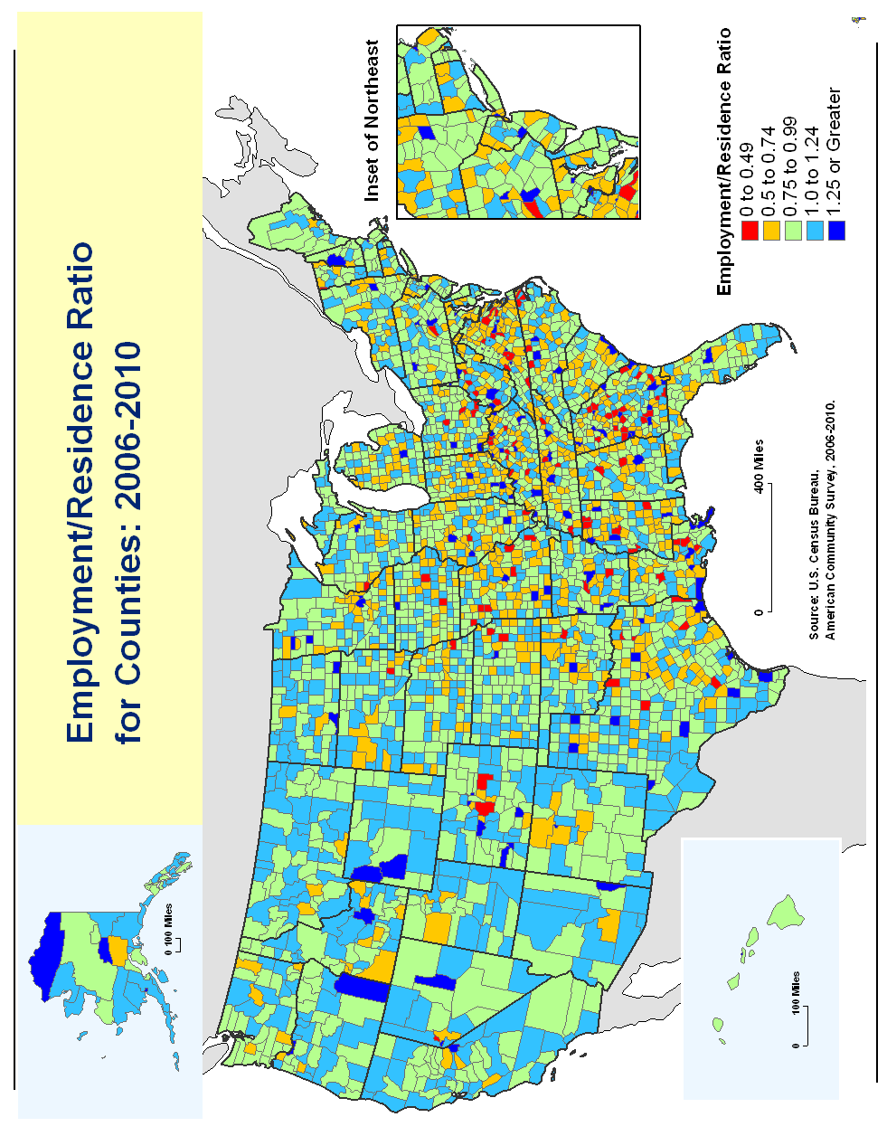

ADDING POPULATION CHARACTERISTICS TO COMMUTER-ADJUSTED POPULATION ESTIMATES
In addition to total population counts, ACS data provide the tools to examine commuter-adjusted population estimates for specific population subgroups. The daily experience of workers may vary by population characteristics such as age, sex, industry, occupation, race, and others. Some areas may attract a relatively large number of workers with certain characteristics, and commuting information broken down by characteristics refines commuter-adjusted population estimates to illuminate such patterns. For example, it is possible to determine the percentage of the commuter-adjusted population who are male or female, over a certain age, or are of Hispanic origin. Table 7 provides an example of the commuter-adjusted population of New York County, NY broken down by sex. It shows that the ratio of males to females is higher for the commuter-adjusted population than that of the resident population. More females live in New York County than males, but once the inflow and outflow of workers is accounted for the number of males exceeds that of females during a typical workday.
Table 8 lists the population characteristics and corresponding tables that may be used to estimate commuter-adjusted population. All of the tables listed are available through American Factfinder. For example, Table B01001 provides residence population by age, and Table B08501 provides its workplace-based counterpart. These tables may be used in the same way that basic population tables are used to obtain commuter-adjusted population estimates for specific groups. If desired, margins of error for commuter-adjusted population estimates using characteristics must be calculated separately.

EXPANDING THE CONCEPT OF COMMUTER-ADJUSTED POPULATION
Beyond worker-based population adjustments, estimates of population change throughout the day may incorporate population components that influence the broader concept of daytime population change. For example, the worker population does not include people younger than 16 years of age, so information about the number of children in daycare centers and the number of students in schools and universities would improve estimates of the daytime population for a given area. Information about tourism is also a valuable piece to the complex and difficult-to-measure concept of daytime population. The number of people staying in hotels may contribute to both the daytime and nighttime population of a community and their contribution may vary considerably across the calendar year. For emergency response purposes, more extensive commuter-adjusted population measurement techniques might place a greater emphasis on capturing variations in mobility options across populations. For example, neighborhoods with high proportions of zero-vehicle households may be particularly vulnerable in their limited mobility options during a disaster.
Such refinements to the daytime population concept require integrating information from multiple data sources and are beyond the scope of this project. A possible enhancement to daytime or commuter-adjusted population estimates could incorporate administrative records data. Administrative records data may potentially supplement ACS survey data and expand the range of topics available for analysis. Future projects related to daytime or commuter-adjusted population estimates may gradually incorporate some of the aforementioned population components and data sources. Estimates aimed at measuring the number of people present in an area during a specific time may fall within a wide range of methodological complexity that depends on data availability and the desired detail of the measure. The ACS-based commuter-adjusted population estimates provide a standardized, widely available, and relatively basic measure that may serve as a baseline for more detailed analysis.

SOURCE AND ACCURACY
This report is released to inform interested parties of ongoing research and to encourage discussion of work in progress. The views expressed are those of the authors and not necessarily those of the U.S. Census Bureau. The data presented in this report are based on the ACS sample interviewed during the 5-year period of 2006-2010. The estimates based on this sample approximate the actual values and represent the entire household and group quarter population. Sampling error is the difference between an estimate based in a sample and the corresponding value that would be obtained if the estimate were based on the entire population (as from a census). For estimates presented in this table, measures of the sampling errors are provided in the form of margins of error in the corresponding table available for download online. All comparative statements in this report have undergone statistical testing, and comparisons are significant at the 90 percent level unless otherwise noted. In addition to sampling error, nonsampling error may be introduced during any of the operations used to collect and process survey data such as editing, reviewing, or keying data from questionnaires. For more information on sampling and estimation methods, confidentiality protection, and sampling and nonsampling errors, please see the 2006-10 ACS Accuracy of the Data document at <www.census.gov/acs/www/Downloads/data_documentation/special_data_release/SPT_AIANTAccuracyofData2010.pdf >. For more information about the commuting patterns of U.S. workers, go to the U.S. Census Bureau’s Journey to Work and Migration Statistics Branch Web site, at <www.census.gov/hhes/commuting/ >, or contact the Journey to Work and Migration Statistics Branch at 301-763-2454.

Table numbers are different across surveys.
For 2000 Census commuter-adjusted population estimates, see <www.census.gov/hhes/commuting/data/daytimepop.html>
The ACS uses a series of monthly samples to produce annual estimates. Detailed questions that previously appeared on the decennial census long form are now included in the ACS, and the decennial census now simply produces a count of the nation’s population and a snapshot of its most basic demographic characteristics. The annual sampling rate for the ACS is about 2.5 percent of all housing units and includes residents living in group quarters. Five years of ACS data collection are necessary to achieve a cumulative sample large enough to ensure respondent confidentiality for smaller communities and for small geographies such as census tracts or block groups. For larger geographies, specifically those with populations of 65,000 or greater, estimates are available annually. For selected geographies with populations of 20,000 or greater, combined 3-year estimates are available.
See www.factfinder2.census.gov.
See www.census.gov/hhes/commuting.
Measures of ACS quality—including sample size and number of interviews, response and nonresponse rates, coverage rates, and item allocation rates—are available at <www.census.gov/acs/www /methodology/methodology _main/>.
See www.census.gov/acs/www/guidance_for_data_users/comparing_2010/, www.census.gov/acs/www/Downloads/library/2007/2007_Jiles_01.pdf.
See www.factfinder2.census.gov.
Instructions for applying statistical tests to ACS estimates can be obtained at: www.census.gov/acs/www/Downloads/data_documentation/Statistical_Testing/ACS_2008_Statistical_Testing.pdf.

