How to Find Statistics for Your Neighborhood Using 2007-2011 ACS 5-Year Estimates
Imagine looking at your neighborhood through a magnified lens as it relates to surrounding geographies. It could expand from being within a block group to representing part of a county, for example. Here are some tips on how to access population estimates and characteristics about your neighborhood at various geography levels, using the latest ACS 5-year estimates.
- County
- County Subdivision
- Zip Code Tabulation Area (ZCTA)
- Census Tract
- Block Group

Below are steps to find statistics for these areas.
County level
- Go to http://factfinder2.census.gov
- Click the “Topics” button (left side of page)
- Click “Dataset”
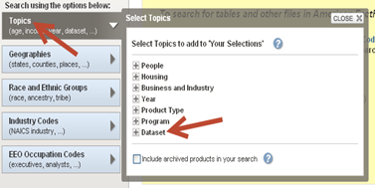
- Click “2011 ACS 5-year estimates”
- Then, close the “Topics” window
- Click “Geographies” (left side of page)
- Click the “List” tab (the “Name” tab can also provide geographies)
- Click arrow for the column Select a Geographic type
- Select “County”
- Select a “State”
- Highlight the county(s) of choice
- Click “Add to Your Selections” (You can click the “MAP” tab to see a map of your geographic selections)
- Close the Geography window
- Click and Select additional “Topics” (left side of page) to narrow the selection of tables in your Search Results
- Select the table(s) to view or download from the Search Results.
Note: Downloading from the Table View will provide more download options than downloading from the Search Results view.
County Subdivision
- Go to http://factfinder2.census.gov
- Click the “Topics” button (left side of page)
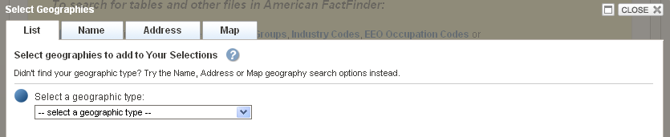
- Click “Dataset”
- Click “2011 ACS 5-year estimates”
- Then, close the Topics window
- Click “Geographies” (left side of page)
- Click the “List” tab (the “Name” tab can also provide geographies)
  - Click arrow for the column Select a Geographic Type
  - Select “County subdivision”
  - Select state and a county
  - Select the county subdivision(s) of choice
  - Click “Add to Your Selections” (You can click the “MAP” tab to see a map of your geographic selections)
- Close the Geography window
- Click and Select additional “Topics” (left side of page) to narrow the selection of tables in your Search Results
- Select the table(s) to view or download from the Search Results.
Note: Downloading from the Table View will provide more download options than downloading from the Search Results view.
Zip Code Tabulation Area (ZCTA)
- Go to http://factfinder2.census.gov
- Click the “Topics” button (left side of page)
- Click “Dataset”
- Click “2011 ACS 5-year estimates”
- Then, close the “Topics” window
- Click “Geographies” (left side of page)
- Click the “List” tab (the “Name” tab can also provide geographies)
  - Click arrow for the column Select a Geographic Type
  - Select “5-Digit ZCTA”
  - Select a state
  - Highlight the ZCTA(s) of choice
  - Click “Add to Your Selections” (You can click the “MAP” tab to see a map of your geographic selections)

- Close the Geography window
- Click and Select additional “Topics” (left side of page) to narrow the selection of tables in your Search Results
- Select the table(s) to view or download from the Search Results.

Note: Downloading from the Table View will provide more download options than downloading from the Search Results view.

Census Tract
Please note that there are two set of instructions for obtaining data by Census Tract. If you do not know your Census Tract, read the section that says, “How to Locate your Census Tract?” If you already know your Census Tract please proceed to “Know your Census Tract…START HERE!.”
How to Locate your Census Tract?
Note: If you already know your Census Tract number, scroll down to the section that reads, “Know your Census Tract? START HERE!”
- Go to http://factfinder2.census.gov
- Locate Address Search (far right side of page)
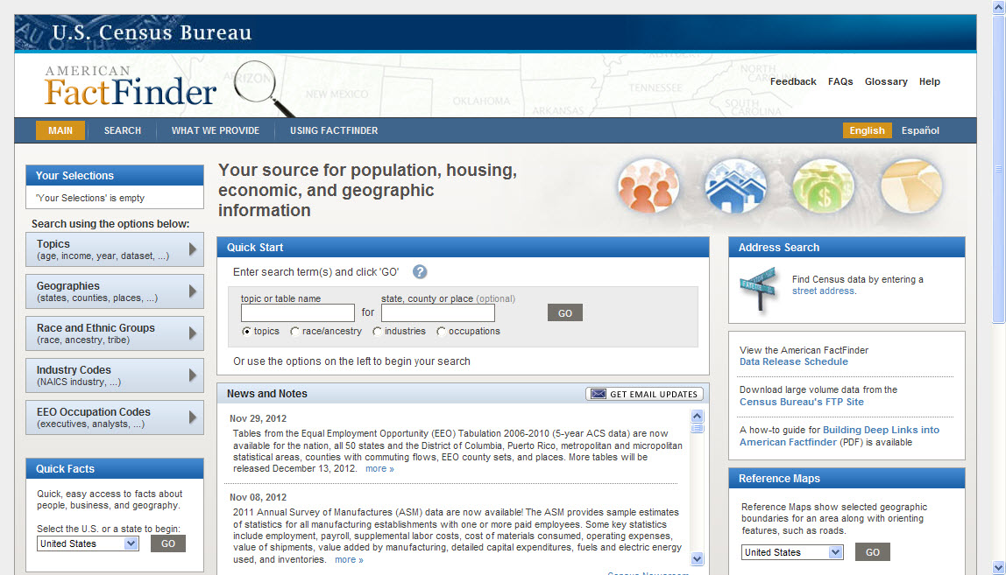

- Click on link “Street Address” (in blue) Note: “Select Geographies” box will appear in the center of the page.
- Type in the complete address.

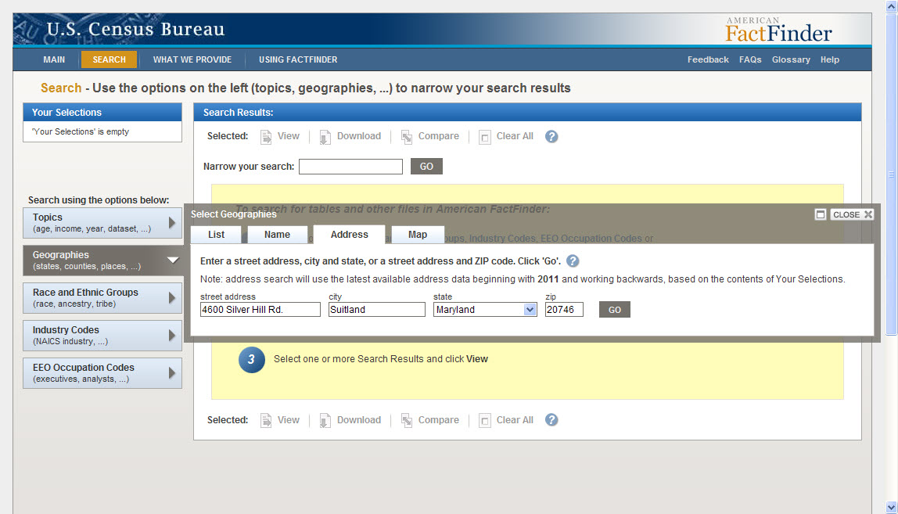

- Click “Go” Note: The “Geography Results” box will appear in the center of the page.
- Scroll down to the geographic type “Census Tract”
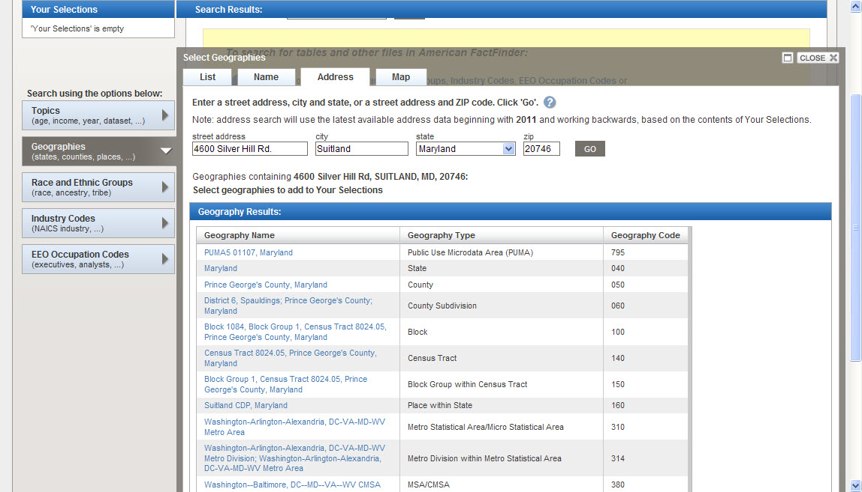

- Click on Census Tract
- Close the Geography window
- Click and Select additional “Topics” (left side of page) to narrow the selection of tables in your Search Results
- Select the table(s) to view or download from the Search Results.

Maps for referencing census tract boundaries are also available in PDF format at: http://www.census.gov/geo/maps-data/maps/reference.html\

Know your Census Tract…START HERE!
- Go to http://factfinder2.census.gov
- Click the “Topics” button (left side of page)
- Click “Dataset”
- Click “2011 ACS 5-year estimates”
- Then, close the Topics window
- Click “Geographies” (left side of page)
- Click the “List” tab (the “Name” tab can also provide geographies)
  - Click arrow for the column Select a Geographic Type
  - Select “Census tract”
  - Select a state
  - Select a county
  - Highlight the Census tract(s) of choice
  - Click “Add to Your Selections” (You can click the “MAP” tab to see a map of your geographic selections)
- Close the Geography window
- Click and Select additional “Topics” (left side of page) to narrow the selection of tables in your Search Results
- Select the table(s) to view or download from the Search Results.
Note: Downloading from the Table View will provide more download options than downloading from the Search Results view.
Block Group
ACS 5-year estimates at the block group level are not available in American FactFinder. They are available through the ACS Summary File. Instructions for accessing block group level estimates through the Summary File Retrieval Tool are available on the ACS Summary File page.
- Visit http://www.census.gov/acs/www/data_documentation/summary_file/
- Select “User Guide: Summary File Excel Retrieval Tool
- Look under “Tools for using the ACS Summary File”.

If you have additional questions, contact the American Community Survey staff at acso.users.support@census.gov or 301-763-1405.

Census Bureau Regional Offices Contact Information

Data users are invited to contact their local Regional Office for data assistance.

Atlanta
404-730-3833
States:
FL, GA, AL, MS, LA, SC, NC

Chicago
630-288-9250
States:
IL, MN, WI, IA, MO, AR IN, MI

Denver
720-962-3700
States:
CO, MT, ND, SD, WY, UT, NE, KS, AZ, NM, OK, TX

Los Angeles
818-267-1725
States:
CA, NV, ID, OR, WA, AK, HI

New York
212-584-3440
States:
NY, ME, VT, NH, MA, RI, CT, NJ/PR

Philadelphia
215-717-1820
States:
PA, OH, WV, KY, TN, VA, DC, DE, MD

